1. 
2. We know that based on file’s content, hash code is generated and then the generated blob is stored under .git/objects creating a new folder whose name is first 2 characters of the hash code and blob is stored inside this folder and its name is the remaining hash characters.   
   **Conclusion**: HashCode(key):file’s content = blob (value)
3. 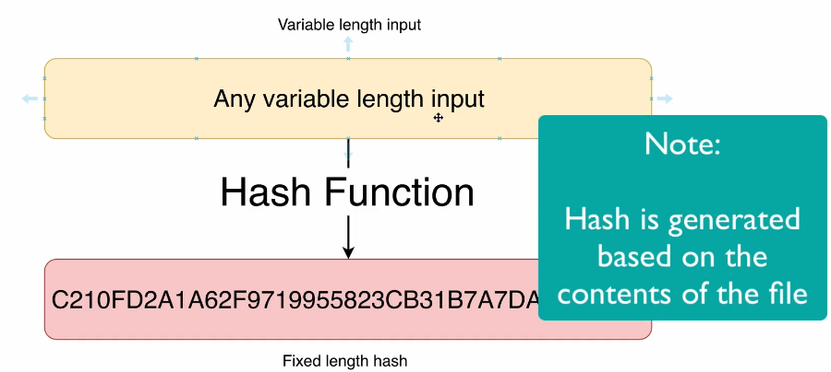
4. 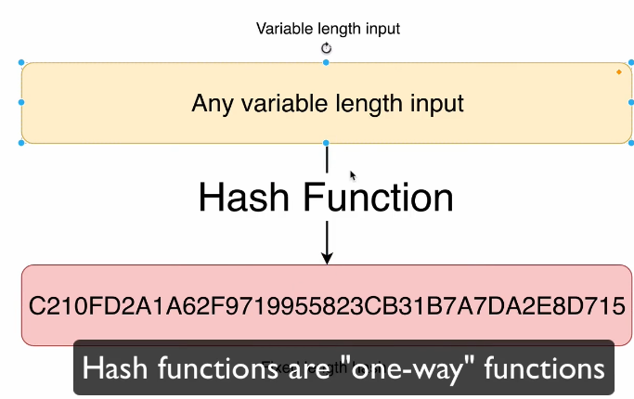****  
   **NOTE**: From hash code, we can’t go back to origin input.
5. 